THE IMPACT OF NEO-LIBERALISM ON TAIWANESE HIGHER EDUCATION
International perspectives on education and society, Vol. 9, 297-311.

Chuing Prudence Chou
Copyright r 2008 by Emerald Group Publishing Limited
All rights of reproduction in any form reserved
ISSN: 1479-3679/doi:10.1016/S1479-3679(08)00010-8

As the world changed into a knowledge-based economy and with the globalization forces continuing to proceed in an unprecedented way, higher education systems have become one of the national imperatives for international competitiveness. Moreover, the impact of globalization has received mixed results. The Internet and the scientific community have created a new world fullof more accessible and transparent knowledge; whereas the increasing world wide inequality of educational resources and university expansion in the name of massification of higher education challenges many developing societies (Altbach,2004; Yang, 2003). It is also argued that globalization has transformed public universities from a public entity into private commodities and consequently increased the number of private higher education institutes (HEIs). Moreover, in order to meet the new global challenges, universities are mandated to respond by restructuring their format, operation, management, and even mission of learning. Policy-makers across the world also have started to reexamine universities’ funding scheme, especially the public ones’, with the hope to recognize universities based on efficiency and accountability (Hooker, 1997).
The author would like to acknowledge Professor Amy Roberts, Mr. Stephen Kosak, and Gregory Ching for their editing assistance.

Along with the above-mentioned challenges in higher education, Taiwanese universities have also gone through a great transformation as the country enforced governmental restructuring policies by embracing the global neo-liberal ideology since late 1980s. In this chapter, the author attempts to explore issues such as the origin of Taiwanese higher educational changes, the format and profile of the change, and the possible future of Taiwanese higher education under the influence of market economies.
Until the lifting of martial law in 1987, higher education had long been controlled by the Taiwanese government due to the political tension between Taiwan and China which started in 1949. Since then, higher education has come into a period of dramatic transformation alongside the introduction of market mechanisms into the education system in the early 1990s. First, the 1994 University Law was passed to reduce the power of the central government by granting more academic autonomy, institutional flexibility, and self-reliance to universities. Meanwhile, Taiwan also experienced an unprecedented expansion in universities and student enrollments as a result of public elections and economic deregulation. Following this expansion, private higher education institutions came to outnumber public; the latter traditionally have enjoyed more resources and social prestige. Yet with the global influence of neo-liberalism, which focuses on privatization and gives privileges to the market economy, more and more universities are considered to be fee-charging and public institutions are suffering from shrinking government funding thanks to the expansion of higher education (Chang & Ho, 2007; Mok, 2003). The consequences of neo-liberalism in Taiwanese higher education have been mixed. Nevertheless, these results may provide valuable lessons to those countries whose universities are also in the process of transformation and expansion.
NEO-LIBERALISM AND HIGHER EDUCATION
Worldwide systems of higher education are experiencing intense and unprecedented transformation, both in its operation and in their relationship to governments. The adoption of neo-liberal, free-market economic policies in the 1980s, and the consequent deregulation of education has impacted many systems in Europe, North and South America, and Asia (including New Zealand and Australia) (Olssen, 2002). Many of these nations have restructured their systems of public education in an attempt to acquire relative autonomy and to assume responsibility as individual institutions. As a result of deregulation and liberalization, the trends of individual institutions are to become more competitive and accountable by creating an overall market mechanism within the education system (Giroux,2002; Dale, 2001). The issuance of educational loans by the International Monetary Fund (IMF) and the World Bank (WB) supports these trends. In general, the IMF and WB serve as a support mechanism for neo-liberalism in Latin America, Africa, and Eastern Europe by the promotion of market mechanisms which effect increases in private investment in education and accountability in higher education institutions (Chou, 2003).
As governments pursue this ideology, systems of higher education (HE) are consequently faced with a series of transformations, shifting from more specific norms of state control to those of state supervision (Song, 2005). In brief, government involvement has shifted from mandating rules and regulations for HEIs to specifying funding standards for universities and colleges to compete based on accountability and performances. Market-oriented higher education is becoming primarily focused on structures and actions tailored to competitionand deregulation. In concrete terms this includes: performance-based funding schemes; increased competition for resources; encouragement of fund-raising by universities; growing numbers of private institutions; the deployment of external evaluation; and rising tuition fees (Dai, Mok, & Xie, 2002; Yang, 2001). Policy-makers are convinced that adopting market-oriented mechanisms will encourage universities to share the financial burden, especially in light of the expansion of student enrollment (Rhoads, 2006). This stance also facilitates the idea of cost-effective among HEIs, in terms of increasing the efficiency and improving educational quality. The positive impact is assumed to enhance institutional academic autonomy, as well as increase choice for students and parents as empowered customers in higher education.
As a global trend, the establishment of market economies has particularly affected Asian HEIs, especially in China, Japan, Korea, and Taiwan, where higher education has experienced tremendous expansion since last decade (Altbach, 2004; Mok, 2003). In this chapter, the system of higher education in Taiwan is used to examine some of the trends associated with the globalized market economy. The case of Taiwan serves as an excellent example given the influence of neo-liberal principles in higher education policy since late 1980s when the country was in the process of political and economic transition.
WHAT INITIATED CHANGES IN TAIWANESE HIGHER EDUCATION?
In this chapter, higher education is defined as four-year comprehensive and technology universities that grant academic degree in Taiwan. Post-secondary The Impact of Neo-Liberalism on Taiwanese Higher Education 299 education in Taiwan that includes three years of junior college or, usually, four years of college/university with the exception of departments such as dental and medical science, which take six and seven years, respectively (Pan & Yu, 1999).
According to national statistics, Taiwan’s old profile as one of the most equitable societies, due to low university tuition fees and associated social benefits, has shifted during the last fifteen years (Chen, 2006; Ministry of Education, 2007a). The 2001 National Annual Statistics report suggested that an income discrepancy between the top 10% and the bottom 10% of families has reached 161 times, in contrast to 39 times the previous year and 19 times in 1991. In comparison of annual family income differences, the gap between the top 20% and the bottom 20% was 7.45 in 2006 and only 4.97 in 1992. These statistics suggest that lower-income families presently earned less in comparison to fifteen years ago (Ministry of Education, 2007b). As a result of increasing income inequities the dream of upward mobility has become infeasible in recent years. Increasing university tuition and shrinking public school funding in the name of market economies has also contributed to this dilemma.
In Taiwan institutions of higher education are, on the one hand, expected and obligated to represent national identity as well as the individuality of the institution. On the other hand, they serve as participants in the market of global competition sparked by processes of internationalization, globalization, and marketization in the Asia-Pacific region (Mok & Welch, 2003). Taiwanese universities entered an era of dramatic development after the lifting of martial law in 1987. This event marked the end of four decades of authoritarian leadership and the beginning of cross-strait dialogues between China and Taiwan. The efforts of advocates promoted social changes such as the abolishment of media censorship, autonomy of decision-making processes within banks, and provisions for promising college students to concentrate their academic interests within Taiwan’s emerging high technology-oriented industries. During this transitional era Taiwan’s school system was criticized for its inability to evolve with the shift of social and academic ideas.
In response, the national government introduced market-oriented reforms to relieve budgetary pressures and to increase the autonomy of HEIs. The Educational Reform Committee (1994–1996) was established to publish five reform papers which served as guidelines for launching a nationwide reform movement (Chou, 2003). Concurrently the revised University Law (1994) was passed to facilitate the introduction of market reforms in Taiwan. The revised University Law impacted the Taiwanese governmental domination of higher education system in terms of the extent of control the Ministry of Education had over HEIs and campus operations (Tsai, 1996). The reforms promoted a diversified system of higher education; institutions gained autonomy in the appointment of presidents, as well as the decision-making process for determination of tuition fees, course offerings, and student recruitment. As a result the Taiwanese system of higher education dramatically expanded. A pivotal outcome of the reform efforts has been the creation and development of private HEIs.
WHAT CHANGES HAVE OCCURRED IN TAIWANESE SYSTEM OF HIGHER EDUCATION?
The impact of neo-liberal ideologies and market economies introduced in Taiwan during the previous two decades is clearly evident within the Taiwanese system of higher education. With this in mind the following section explores associated issues and dilemmas affecting university expansion, institutional autonomy, external funding and tuition fees, and global competitiveness.
In terms of university expansion, it is important to note that there has been long-term growth in the number of HEIs. In 1987 Taiwan had a total of 107 universities and colleges which expanded to 130 in 1994 and 163 in 2006 (Fig. 1 and Table 1) (Ministry of Education, 2007a). The introduction scheme reinforced university expansion. New reform programs including selection of textbooks, multiple routes for high school and university entrance exams, and expansion of high schools and universities . A
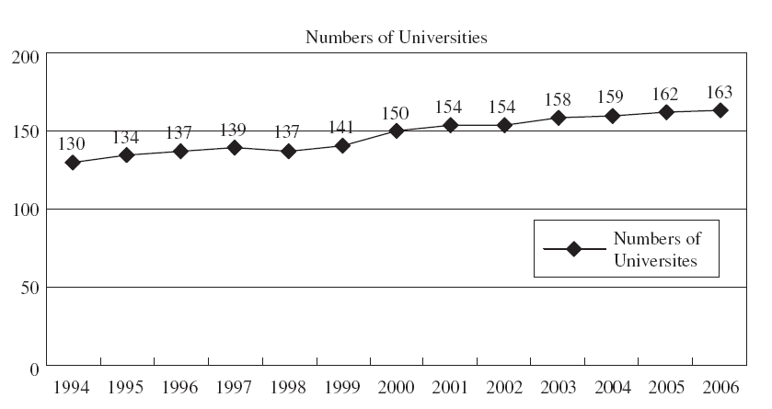
Fig. 1. Growth of Taiwanese Universities.
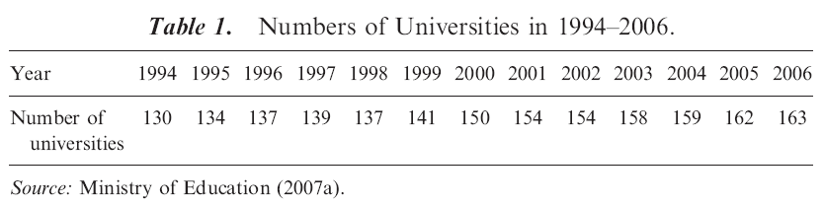
U : Among the expansion, the ratio of public to private institutions, 1:1.96 (55:108) (Ministry of Education, 2007b), indicates that the expansion of higher education in Taiwan can be accounted for mainly by increasing private institutions. Private institutions accommodate more than 70% of the student population and charge twice as much in tuition in contrast to public universities. In Taiwan, public institutions are still regarded as more prestigious than their private counterparts. It has been argued that the expansion of HEIs since 1990s occurred largely because of the upgrading of existing institutions (especially from private vocational high schools and two-year colleges), although other strategies, such as splitting, merging, and increasing the size of the existing institutions, were also used to develop ‘‘new’’ institutions (Tsai & Shavit, 2003).
The trend of institutional expansion can be merged with a consistent growth in the net enrollment rate of higher education among the 18–22 age cohorts, particularly among female students (which now constitute more than 45% of enrollees) (Chou & Ho, 2007b).The effects of institutional autonomy follow a similar trend. In reaction to pressures to institute market mechanism, MOE and the Executive Yuan Education Reform Committee of 1994–1996 analyzed several influences in higher education associated with the employment of market mechanisms. In the early 1990s they responded with a call for deregulation of the HE system. As such the government’s role was transformed to one of regulator and facilitator.
Deregulation occurred concurrently with university expansion. This meant that a growing number of new students, supported by government funds constituted a financial burden for the government and the institutions. The government could no longer afford to financially support higher education; rather its new chare was to simply supervise HEIs through theSource: Ministry of Education (2007a). University Law and other state regulations. To facilitate this process, the Ministry of Education initiated a proposal regarding the incorporation of universities, enabling public institutions to become independent, efficient, and autonomous entities under the protection of law (Huang, 2003). In 2004 this process was initiated with an added chapter to the University Law, referred to as the ‘‘Incorporation of Universities’’ (Huang, 2003). The proposal was not completely approved in the Legislative Yuan 2005 due to a lack of consensus from the general public and leading universities across the island. However, most public HEIs started implementing the market economies by revising staff employment guidelines which had a different system from faculty employment.
In another effort to upgrade higher education quality in terms of improving efficiency and accountability, the MOE in Taiwan initiated the‘‘1999 Project for Pursuing Excellence in Higher Education.’’ Four years later the ‘‘White Paper Report on Higher Education in Taiwan’’ was launched. The latter summarized the most recent developments of higher education in Taiwan and recommended a range of measures to achieve excellence in higher education (Laws and Regulations, 2004). To improve university financing, the government proposed changing the ratio and method of funding, and at the same time encouraging public universities to search for other ways of raising revenue, such as opening up EMBA (Executive Master of Business Administration) courses, offering continuing education for senior managerial staff in enterprises or government business administration departments, cooperation with enterprises for sponsorships, adult and continuing education, and the like (Dai et al., 2002).
The Ministry of Education and the Education Reform Committee also suggested that Taiwanese universities and colleges were too homogeneous in terms of their functions and goals. To assist higher education institutes in becoming diversified, the MOE and Education Reform Committee recommended that HE should be differentiated in their characteristics and mission (Yang, 2001; Hsieh, 1997). As such existing salary scales – based largely on seniority – were viewed as insufficient to promote the desired competition among faculty for state-of-the-art in teaching and research. To increase faculty competitiveness the Education Reform Committee suggested a competitive reward system to replace the old fixed one. The MOE attempted to lessen its control over the establishment and enforcement of curriculum requirements; guidelines to allow for competing resources, as well as financial subsidies based on merit and performance evaluation of universities were established.
Although the White Paper Report initiated controversy among critics, most of its policies were implemented (Ministry of Education, 2003). Universities and colleges now experience increasing pressure from the market and government to compete for resources, funding, and student recruitment. The importance of meritocracy, accountability, and networking among faculty and staff has dramatically increased (Chen, 2007). Moreover, the introduction of market mechanisms into universities shifted the expense of higher education from a public service to the responsibility of citizens. In regard to university budgets, the proportion of financial support from the MOE decreased from 62.7% in 2000 to 49.2% in 2006, whereas the proportion of tuition income increased from 12.83% to 21.59% (Chou, 2007; Chang & Ho, 2007). Accordingly, an ‘‘Administrative Funding Scheme’’ was introduced into public universities to improve accountability. No longer relying on government budgets alone, public (or the so-called ‘‘national’’)universities are required to designate partial funds for sharing administrative costs. The MOE and other government budgeting offices still have the right to regulate various university practices. Consequently, the MOE started a trial program based on these principles with five universities in 1996, allowing them increased autonomy in the allocation of resources. At present 55 out of 70 public universities participate in this program (Table 2) (Chang & Ho, 2007; Ministry of Education, 2007a).
Table 2. Source of Administrative Fund for Public Universities.
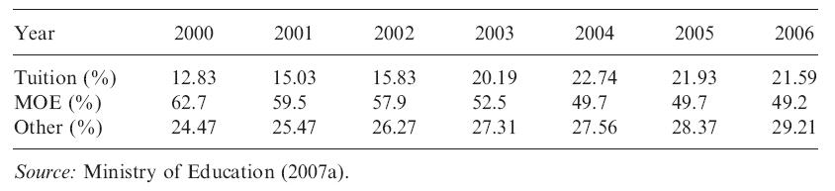
To become financially self-sufficient, leading universities have initiated unprecedented fund-raising campaigns, gathering donations from their alumni, general public, and various enterprises. However, many institutions have been less than successful in obtaining significant support from these sources, due to the lack of an established alumni network. Universities of lower prestige, private institutes, and those without wealthy alumni face further fund-raising challenge (Chen, 2003) (Table 3). In addition, the increase HEI tuitions has become a heavy burden for many students across Taiwan. From 1997 to 2006, tuition at public universities has increased approximately 42%, while private universities have experienced a 14% increase (on an already high-cost base). As indicated before, the expansion of higher education in Taiwan is mainly the less-advantaged family backgrounds (Chou, 2007). The increased university tuition among private HEIs has become an extra burden to families in Taiwan because most parents (GDP ?15,640 USD in 2006) incur the additional expense, especially for students who attend private institutions (Tang, 2007). As a result more than half of the total university student population in Taiwan has student loans or part-time jobs (Chou, 2007).
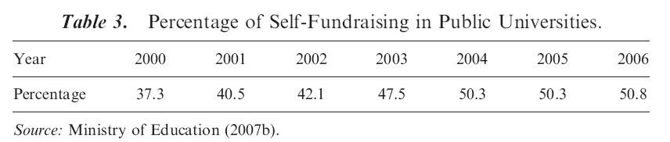
HOW DOES TAIWAN PURSUE WORLD-CLASS UNIVERSITIES?
The Taiwanese government has given high priority to the global competitiveness of higher education and to the development of a knowledge- based economy. This trend is clearly evident within the top universities, particularly prestigious public institutions. The current reform policy, to upgrade the capacity and quality of higher education in Taiwan, targets only a small number of top universities with the goal to gain recognition within the realm of the so-called ‘‘top 100 world-class universities’’ (Huang, 2003; Lu, 2005). Since 2003, MOE has promoted a ‘‘World Class Research University’’ project, which proposes to upgrade at least one Taiwanese university to the ranks of the top 100 leading international institutions of higher education. To support this effort, MOE developed a ‘‘five-year, fifty billion budget’’ (an estimated US$1.6 billion) in 2006. The budget serves to empower potential universities to improve their fundamental development, to help them integrate human resources from different departments and disciplines, and to establish research centers of cutting-edge specialized research (Ministry of Education, 2006). Twelve universities (two private HEIs) were selected and granted a bulk fund in 2006.
Recently, there has been debate concerning what constitutes the ‘‘top 100 world-class universities,’’ who defines them, and according to whose standards (Altbach, 2003; Hwang, 2003). Without a doubt, universities in Taiwan, even the most prestigious ones such as the National Taiwan University (NTU), have been striving for international competitiveness among professoriate. Like NTU, many universities, public or private, are now required to establish an internal and external faculty evaluation system to monitor their publication records in various international databases such as the Science Citation Index (SCI), Social Science Citation Index (SSCI), the Engineering Index (EI), etc. (Approaching the worldclass universities scheme, 2005; Chou & Ho, 2007a). The evaluation system is an effort to become aligned with international standards leading to awards, achievements, and contributions to academic knowledge (Altbach, 2003; Mok, 2003). As a result, the ‘‘Higher Education Evaluation and Accreditation Council of Taiwan’’ was established in 2006 as a semi-governmental agency to conduct university evaluations on a regular basis. It is hoped that this organization will provide constructive evaluation reports for institutional improvement and recommendations for public funding references.
WHAT ARE THE RESULTING CHALLENGES IN HIGHER EDUCATION?
As indicated earlier, the adoption of neo-liberal, free-market economic policies, and consequent deregulation of education is an attempt to increase the relative autonomy and responsibility of individual institutions. By deregulation and liberalization, each HEI is expected to become more competitive and accountable. However, in recent years the influence of this market trend within university reform has created some controversy.
First, the road to reform for higher education in Taiwan and its related pursuit of world-class standards has revealed significant challenges that the country must confront and overcome to achieve these goals (Chou, 2005; Lu, 2005). In Taiwan, universities, especially the public ones, have long been viewed throughout the culture and society as a public good which are accessible to anyone who can pass the college entrance exams, regardless of the ability to pay. The introduction of neo-liberal ideology and its various market-oriented commodity outcomes has transformed higher education into a more personalized option for individuals based on family income and investment decisions (Chang & Ho, 2007).
Secondly, in response to market-oriented demands, HEIs are pressured to reorganize their departments and coursework according to the perceived dictates of the market. Students, keen to enhance their job prospects, tend to take courses that they can link to ‘‘practical outcomes’’ rather than to‘‘theoretical foundations.’’ Institutions are viewed as trainers of academic entrepreneurs pursuing professional knowledge as a matter of business, rather than as facilitators of truth or discovery (Tsai & Shavit, 2003). The short-term and possibly short-sighted implications for research conducted in this new market environment seem obvious.
Moreover, as a result of the shrinking public funding opportunities, universities now are pressured to engage in fund-raising from business enterprises and corporations. The shift away from government financial support may be transforming higher education into institutions molded by the interests of the business world (Chen, 2003).
In addition, schools and departments of liberal arts are forced to transform either their names or programs to remain competitive. Programs downsizing or even closing down because of the shrinking opportunities for their graduates in the job market (Olssen, 2002; Chou & Ho, 2007a). Courses that relate to critical theory, literature, philosophy, and other nonapplied subjects are today becoming regarded as ‘‘cold disciplines,’’ meaning they have lost popularity due to their lack of immediate value in the job market.
Above all, tuition increases in both public and private HEIs have become a heavy burden for many students across Taiwan. During the period from 1997 to 2003, tuition at public universities has increased approximately 40%, while private universities have experienced a 12% increase from an already high base (Chang & Ho, 2007; Ministry of Education, 2005). In 1995, educational expenses for universities were approximately 80,000 NT (US$2,500) per student per year; by 2002, that number had increased to 120,000 NT (US$3,800) per student (Chou, 2007; Chang & Ho, 2007; Ministry of Education, 2005). Families have to bear these high costs, especially for students who attend private institutions. The latter make up about 66% of the total universities and colleges in Taiwan (Fig. 2 and Table 4). As a result of the rapid expansion of HEIs and the restriction of government funding, higher education has gradually transformed into a private business negotiation.
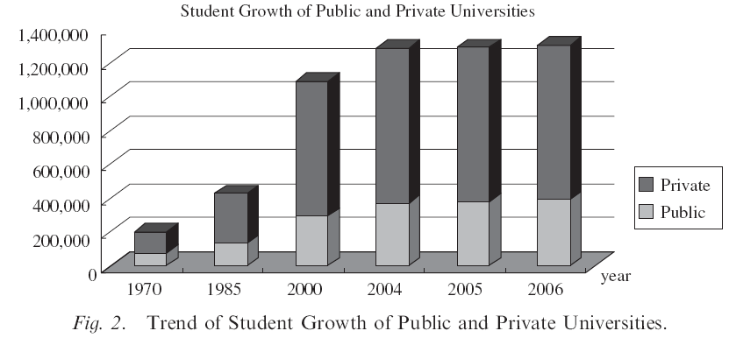
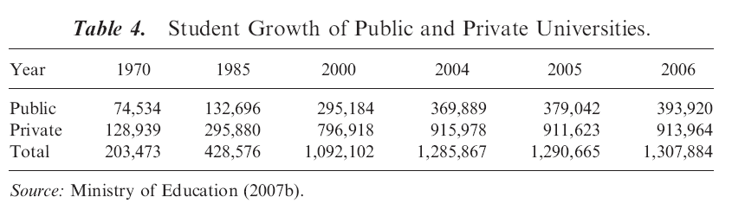

WHAT WILL HAPPEN NEXT TO TAIWANESE HIGHER EDUCATION?
As indicated earlier, Taiwanese higher education, was until the late 1980s, administered by the government. Alongside the general trends toward political democracy and economic deregulation, coupled with the influence of the global advance of neo-liberalism ideology, Taiwanese higher education went through a period of great transformation. In the early 1990s, the general public called for the government to withdraw its control over universities, to allow autonomy, efficiency, and flexibility in university decision-making and daily operations (Chou, 2003; Hwang, 2003). Under this public pressure, a series of reforms aiming at decentralization and deregulation of public institutes were launched to enhance institutional autonomy and academic freedom, which were protected by the constitution.
Specific reforms included: deregulation of government control; privatization of public services; introduction of accountability and competition; shared governance and funding resources between the state and HEIs; and implementation of external evaluation schemes to monitor reform outcomes. Meanwhile college enrollments expanded, university system were restructured, curriculum and instruction were revised, and there was a sharp increase in competition for resources; competition that largely replaced the collegial environment of earlier decades. In addition, many of the national universities are today striving to become world-class institutions, as the government earmarks special bulk funds to upgrade their education (Huang, 2003). In the long run, some leading HEIs in Taiwan have benefited and made significant progress, improving their physical infrastructure and increasing their presence in international research journals. As the years progressed, more and more universities have enjoyed institutional autonomy, but are also facing challenges in fund-raising, accountability, and evaluation (Chang & Ho, 2007).
As higher education reform progresses, there are mixed feelings in all walks of life with regard to the change. Many universities today are providing education with more of an eye toward profit than quality. The implications for educational quality and equity of opportunities tend to be less emphasized in the era of market-driven environments (Olssen, 2002; Mok & Welch, 2003).
In sum, Taiwan has been responding to the global trend toward marketoriented reform to higher education alongside its political and social transformation since the late 1980s. Taiwan’s reforms offer a valuable lesson to other countries, such as China, Japan, and Korea who are also grappling with reforms motivated by neo-liberal ideology. In the 21st century, education, especially higher education, has become more and more desirable, and therefore, should be available to any autonomous chooser in a neo-liberal society according to Foucaudian perspective (Fitzsimons, 2002). Nevertheless, McGinn (1996) and Carnoy (2006) argued that once the global market economies are introduced to a country, the government will eventually lose control over the domestic reform decision-making to its global forces. Several local or international critics (Huang, 1997; Dai, 1998; Altbach, 2003) also urged that any developing or middle-income country should be more aware of the consequences brought on by neo-liberalism, the market economy, and the globalization forces while reforming its higher education system. As countries like Taiwan establish new rules, pulling all educational resources together, in pursuit of the world’s first-class standard, the public mission of university must not be forgotten – preserving, passing, and creating culture and knowledge for the betterment of the human society, and especially the next generation (Hayhoe, 1989, 1995; Zappia, 2000).

REFERENCES
Altbach, P. (2003). Centers and peripheries in the academic profession: The special challenges of developing countries. In: P. Altbach (Ed.), The decline of the Guru: The academic profession in developing and middle-income countries. New York: Palgrave Macmillan.
Altbach, P. (2004). Globalization and the university: Myths and realities in an unequal world. Tertiary Education and Management, 10, 3–25.
Altbach, P. (2005). A world-class country without world-class higher education: India’s 21st century dilemma. International Higher Education, 40.
Approaching the world-class universities scheme. (2005). Ministry of Education, Higher Education Newsletter, p. 178.
Carnoy, M. (2006). Rethinking the comparative – and the international. Comparative Education Review, 50(4).
Chang, K. W., & Ho, M. S. (2007). Half-hearted neoliberal reform: Analyzing Taiwan’s college tuition policy and controversy. Education and Social Studies, 12.
Chen, L. Y. (2007). Implications of competing values framework for developing internalization indicators for higher education evaluation plan. Journal of Educational Administration,3(June).
Chen, T. Y. (2003). A study of self-fundraising strategy and university administrative fund. Available at http://www.nou.edu.tw/Bresearch/data/data_01_39.htm. Retrieved on November 20, 2007.
Chen, Y. L. (2006). The war between 80 versus 800. Business Weekly (Taiwan), p. 954.
Chou, C. P. (2003). The great experiment of Taiwanese education: 1987–003. Taipei: Psychology Publishing.
Chou, C. P. (2005). The influence of neo-liberalism on higher education – New Zealand model. Journal of Education Research (136), 148–158.
Chou, C. P. (2007). Beyond university tuition fee: A nation-wide on-line survey on university student living cost. Journal of Educational Research, 154.
Chou, C. P., & Ho, A.-H. (2007a). Internationalisation of higher education in Taiwan: A case study of National Taiwan University. Unpublished preliminary research findings.
Chou, C. P., & Ho, A.-Hsin. (2007b). Schooling in Taiwan. In: G. A. Postiglione & J. Tan (Eds), Going to school in East Asia. Westport: Greenwood.
Dai, X. X. (1998). Higher education of the new century. Cross-strait Youth Scholar Forum proceedings. Taipei: National Taiwan Normal University.
Dai, X. X., Mok, K. H., & Xie, A. B. (2002). The marketization of higher education: A comparative study of Taiwan, Hong Kong and China. Taipei: Higher Education Publishing.
Dale, R. (2001). Constructing a long spoon for comparative education: Charting the career of the New Zealand model. Comparative Education, 37(4), 493–501.
Fitzsimons, P. (2002). Neo-liberalism and education: The autonomous chooser. In Radical Pedagogy. Available at http://radicalpedagogy.icaap.org/content/issue4_2/04_fitzsimons.html. Retrieved on November 2006.
Giroux, H. A. (2002). Neo-liberalism, corporate culture, and the promise of higher education: The university as a democratic public sphere. Harvard Educational Review, 72(4).
Hayhoe, R. (1989). China’s universities and western university models. In: P. G. Philip & V. Selvaratnam (Eds), From dependence to autonomy: The development of Asian universities. Dordrecht, Netherlands: Kluwer Academic.
Hayhoe, R. (1995). Comparative reflections on the transition to mass higher education in East Asia. Comparative Education Review, 39(3), 299–321.
Hooker, M. (1997). The transformation of higher education. In: D. Oblinger & S. C. Rush (Eds), The learning revolution. Bolton, MA: Anker Publishing Company.
Hsieh, W. T. (1997). Review of the Taiwanese Executive Yuan Education Reform Committee report. Education Research and Information, 5(5).
Huang, C. J. (1997). Problems and solutions on current university education reform. Taipei: Hanwen Publishing.
Huang, J. T. (2003). The current development and challenges of higher education in Taiwan. A speech by Dr. J. T. Huang, Minister of Education, Taiwan, October 13, 2003. Available at http://www.edu.tw/EDU_WEB/EDU_MGT/BICER/EDUANDY001/english/e031018.htm?open. Retrieved on November 29, 2007.
Hwang, K.-K. (2003). What’ wrong with Taiwanese education reform? Taipei: INK Publishing. Laws and Regulations, Database of the Republic of China. (2004). University Law. Available at http://law.moj.gov.tw/Eng/Fnews/FnewsContent.asp?msgid=2307&msgType=en&keyword=undefined. Retrieved on July 9, 2006.
Lu, M. L. (2005). Policies of higher education in Taiwan and the development of private higher education institutions. Paper presented at Seminar of Transformation in University Management – From the perspective of marketization in high education: Its Implication for the relationship private university and Taiwanese government. Taipei, Tamkang University.
McGinn, N. (1996). Education, democratization, and globalization: A challenge for comparative education. Comparative Education Review, 40(4).
Ministry of Education. (2003). White paper report on higher education in Taiwan. Available at http://history.moe.gov.tw/important.asp?id=37. Retrieved on November 25, 2007.
Ministry of Education. (2005). Summary of universities, colleges and junior colleges. Available at
http://www.edu.tw/EDU_WEB/EDU_MGT/STATISTICS/EDU7220001/data/serial/u.htm?UNITID=139&CATEGORYID=260&FILEID=130551&open. Retrieved on July 19, 2007.
Ministry of Education. (2006). Financial report for Public Schools. Available at
http://www.edu.tw/EDU_WEB/EDU_MGT/ACCOUNTING/EDU7538001/Address/Public/Address.htm?
TYPE=1&UNITID=199&CATEGORYID=361&FILEID=142511.
Retrieved on July10, 2006.
Ministry of Education. (2007a). Summaries of universities and colleges, SY 2006-07. Available
at http://140.111.1.22/index.shtml. Retrieved on November 25, 2007.The Impact of Neo-Liberalism on Taiwanese Higher Education 311Ministry of Education. (2007b). Educational Statistics, SY 2006-07. Available at http://www.accounting.tchcvs.tc.edu.tw/. Retrieved on November 10, 2007.
Mok, K. H. (2003). Globalization and higher education restructuring in Hong Kong, Taiwan and mainland China. Higher Education Research & Development, 22(2).
Mok, K.-H., & Welch, A. (Eds). (2003). Globalization and educational restructuring in the Asia Pacific region. Gordonsville, VA, USA: Palgrave Macmillan.
Olssen, M. (2002). The restructuring of tertiary education in New Zealand: Governmentality, neo-liberalism, democracy. McGill Journal of Education (Montreal), 37(1).
Pan, H.-L., & Yu, C. (1999). Educational reforms with their impacts on school effectiveness and school improvement in Taiwan. R.O.C. School Effectiveness and School Improvement, 10(1), 72–85.
Rhoads, R. A. (2006). University reform in global times: Opportunities and challenges. Chung Cheng Educational Studies, 5(1). Song, M. M. (2005). Relationship of government and high education within marketization: Its implications for the role and development of private higher education institution in China. Paper presented at Seminar of Transformation in University Management – From the perspective of marketization in high education: Its Implication for the relationship private university and Taiwanese government, Tamkang University, Taipei.
Tang, H. L. (2007). The disappearing seven years in Taiwan. NPFR Research Report. Available at http://www.npf.org.tw/particle-2110-2.html. Retrieved on November 28, 2007.
Tsai, C. H. (1996). The deregulation of higher education in Taiwan. International Higher Education, Spring. Available at http://www.bc.edu/bc_org/avp/soe/cihe/newsletter/News04/textcy03.html. Retrieved on May 1, 2007. Tsai, S. L., & Shavit, Y. (2003). Higher education in Taiwan: Expansion and inequality of educational opportunity. Paper presented at the International Sociology Association RC28 Research Comty, August 22–24, New York.
Yang, R. (2003). Globalization and higher education development: A critical analysis. International Review of Education, 49.
Yang, S.-K. (2001). Dilemmas of education reform in Taiwan: Internationalization or localization? Paper presented at the Annual Meeting of the Comparative and International Education Society, March 13–17, Washington, DC, USA.
Zappia, C. A. (2000). The private sector and public higher education. Perspectives, May.

